Deactivate Broadband and Voice Service Over Cable

Version Control:

Use Case Name: |  | Deactivate Broadband and Voice Service
Use Case Owner: |  | Sumit Borade
Current Version |  | 0.4
Use Case Version History
Modified Date | Version |  | Modified By | Change Description
June 28, 2009 | 0.1 |  | Tom Schnarr | Initial Version
July 8, 2009 | 0.2 |  | Tom Schnarr | Added Voice scenarios into the use case
July 9, 2009 | 0.3 |  | Tom Schnarr | Changed BACC interaction order to reset device before CM is deleted
August 26,2009 | 0.4 |  | Sumit Borade | Updated for adding the reply step and removed steps not relevant for SMP

Brief Description:
This use case describes the process by which a YouSee subscriber’s broadband and optional voice service is deactivated.

The use case is written from the perspective of the SMP provisioning solution.

Related Documents
- YouSee SMP SOW2Architecture Requirements Document
- YouSee SMP SOW2 Business Requirements Document
- Voice over Cable Use Case Activation
- Cisco BACC TC Specification
- Cisco Subscriber Manager TC Specifications
- Cisco BTS TC Specification
- IP History TC Specs
- Static IP Notification TC Specs

Related Use Cases

Pre-Conditions
- Subscriber is an active broadband over cable subscriber.
- Subscriber may also have voice over cable services.

Post-Conditions
- Subscriber’s service has been deactivated and they can no longer access YouSee Broadband services.

Use Case

Primary Flow Diagram
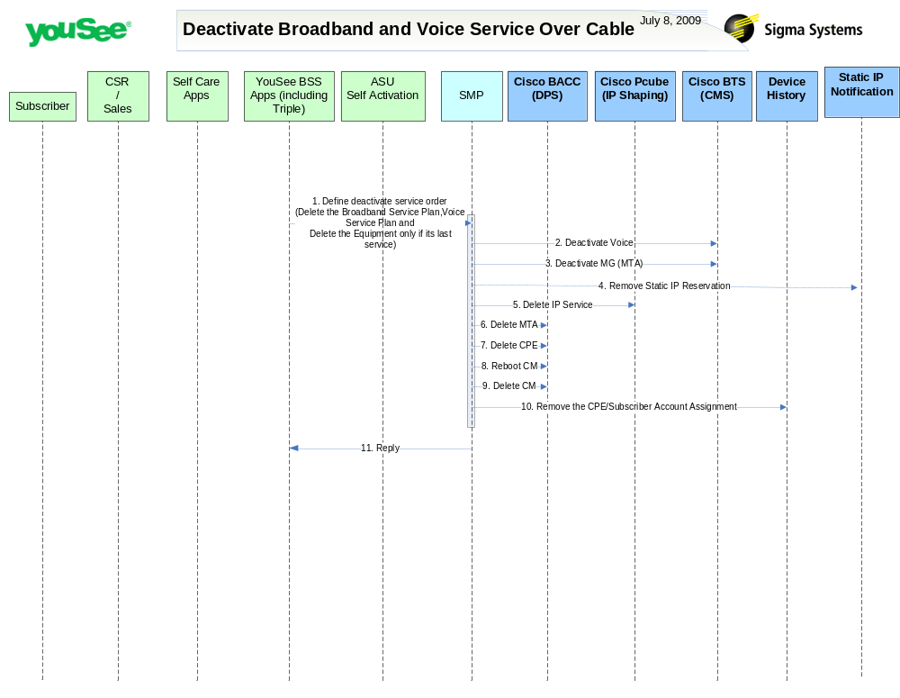

Primary Flow Detail
# | Actor: Key Action | Description | Alternate Flows/Details
 | YouSee BSS: Deactivate Service Order is communicated to SMP | <As in Change service Order>
 | SMP: deactivates Voice Line from BTS | SMP will delete the voice service configuration in BTS including subscriber (line) and MTA (mg)
 | SMP: deactives MTA/MG from BTS | SMP will delete the MTA entity from BTS. BTS recognizes this entity as a MG.
 | SMP: removes the Static IP Reservation | SMP will remove the Static IP Reservation from YouSee static IP Notification System
 | SMP: deletes internet service to Cisco Subscriber Manager | SMP will delete the configuration of the Broadband service in Cisco Subscriber Manager
 | SMP: deletes MTA from BACC | SMP Will deprovision the MTA configuration from BACC
 | SMP: deletes CPE in BACC | For each CPE service, SMP will delete the corresponding entity in BACC
 | SMP: requests BACC to reboot the CM Device | Device is rebooted resulting in it receiving the new configuration.  This needs to occur prior to the CM deletion from BACC as BACC cannot reset a deleted device. This introduces a minor timing issue, but for the vast majority the device is deleted from BACC before it completes the reboot cycle.
 | SMP: deletes CM in BACC | SMP will delete the CM Configuration in BACC
 | SMP: deletes CPE from Device History | SMP will mark the CPE in the device history table as deactivated
 | SMP: Replies back to ASU the status of Activation | SMP will reply to ASU the status of Provisioning Order to ASU. | If Provisioning fails then SMP will put the Failed task in Manual Queue.

